<Deployment of Life Sciences Research Intelligence Dashboard>

Ramana Maharshi Mellacheruvu
Date : 09 June 2026
CONFIDENTIAL

Deployment Process
Run the research_intelligence_dashboard.py Script in vs code using below command(Make sure You have the script downloaded in your working directory).
python -m streamlit run "research_intelligence_dashboard.py"
Deployment Screenshots
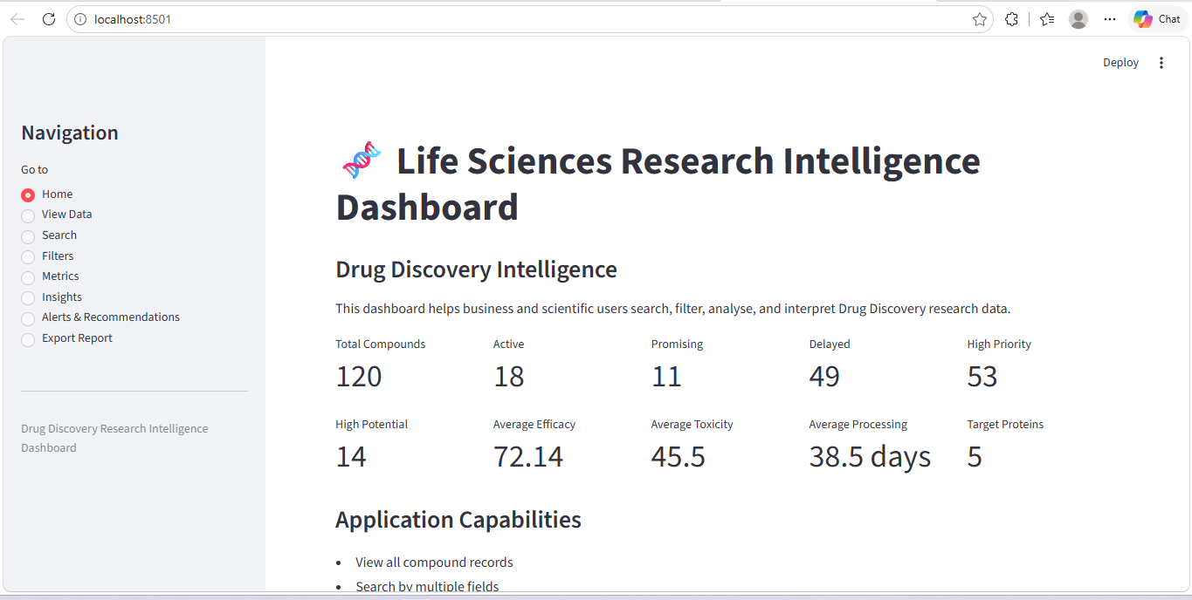
Brief Deployment Summary
The Life Sciences Research Intelligence Dashboard was deployed using Streamlit Community Cloud. The application source code, dataset, and dependency file were stored in a GitHub repository and connected to Streamlit for deployment.
The deployed dashboard allows users to view Drug Discovery data, search records, apply multiple filters, monitor business metrics, review scientific insights, identify operational alerts, generate recommendations, and download reports. Custom CSS was added to improve the interface with a professional background, styled metric cards, a hero banner, modern buttons, and dashboard feature cards.
The deployed application was tested to confirm that the dataset loads correctly, all navigation pages function properly, charts and metrics render successfully, and download options work as expected.


Sub-bullet style

